# Media Analysis - ChatGPT is the ‘Netscape moment’ for artificial intelligence’

## Short Summary

The article presents ChatGPT as a 'Netscape moment' for AI, highlighting its profound influence across industries via Large Language Models LLMs , while acknowledging their limitations in common sense, world knowledge, reasoning skills, and potential misinformation.

## Summary

1. **Exciting Development**: ChatGPT has generated significant excitement globally, similar to the initial impact of Netscape's World Wide Web browser in the 1990s, due to its rich conversational interface built on Large Language Models (LLMs).  
2. **Technological Advancement**: LLMs are trained using unsupervised learning on vast text corpora, enabling them to understand language patterns and generate human-like responses but lacking world knowledge, common sense, or reasoning capabilities.  
3. **Current Limitations**: These models face limitations such as generating false or misleading information due to their inability to discern truth or perform complex calculations, leading to issues like plagiarism and the production of harmful content.  
4. **Future Evolution**: As LLMs evolve rapidly, they will need improvement by systems emulating human-like thinking, including understanding common sense, ethics, and reasoning, which is essential for near-instantaneous decision-making.  
5. **Dual Nature of AI**: While ChatGPT excels at specific tasks like creating contracts or generating content based on prompts, they fall short in complex problem-solving and understanding context deeply due to their lack of 'semantics.'  
6. **Emergence of Foundation Models**: These are general-purpose models that can be trained once and reused across multiple applications with minimal computational cost, providing a new platform for AI development, particularly beneficial in localized markets like Saudi Arabia.  
7. **AI as Productivity Enhancer**: With the rise of automation and inflationary pressures, ChatGPT can enhance productivity by reducing reliance on human labor, making it a valuable tool during economic challenges and demographic shifts in developed countries facing aging populations and declining workforces. Saudi Arabia's focus on data utilization, AI education, and industry-specific developments positions the Kingdom well to capitalize on this opportunity.

## Question 1:

How do the media in this article frame the public discussion about ChatGPT? Are there certain **metaphors** that keep cropping up?

The media in this article frame the public discussion about ChatGPT using metaphors such as comparing it to Netscape making the internet accessible democratizing AI , describing its language capabilities as 'rich' and 'autocomplete on steroids', highlighting its limitations due to lack of common sense or reasoning abilities, and projecting a future where AI will evolve towards more human-like understanding with augmentation by systems possessing ethical considerations.

## Question 2:

Which role does or might the Arabic World play in the development of Artificial Intelligence? Answer with 'Not mentioned' if not applicable.

The Arabic world, particularly countries like Saudi Arabia, is exceptionally well-positioned to capture the AI opportunity due to their strong data recognition capabilities and existing expertise in specific domains such as energy. These entities are investing heavily in developing local AI talent and could potentially contribute significantly to building foundation models that can be widely used.

## Question 3:

Which use cases of Artificial Intelligence are helpful for the Arabic world based on this article?

The use cases of Artificial Intelligence helpful for the Arabic world, as highlighted by this article, include legal automation through AI-powered contract drafting, ethical reasoning and plagiarism detection to ensure reliable outputs, generative content creation for increased efficiency, localization of LLMs to cater to diverse linguistic needs, and domain-specific foundation models that can be made available across various industries in the Arabic world.

## Question 4:

What is the final message of the article that the author wants to convey? Keep your answer short and precise!

Embrace ChatGPT for creating new value in economic challenges, but also recognize the need for AI to evolve beyond current limitations.

## Sentiment

The sentiment is 3

## Entities

Chatgpt, Saudi Arabia Develop Country, Technologist Investment Program, Saudi Public Private Sector Entity Encourage Explore Technology Create New Value, Rst Appear, Ai Exempli Ed, Anthony Butler

## Topic Clusters

### Cluster: AI Impact on Society

ChatGPT's impact, Plagiarism concerns

### Cluster: Unsupervised Learning

### Cluster: Auto-Generated Contracts

Auto-generated contracts

### Cluster: Model Limitations

Model limitations

### Cluster: Productivity Enhancement

### Cluster: De-Aggregation Effects

De-aggregation effects

### Cluster: Demographic Challenges

## Word Clouds

### Wordcloud of content

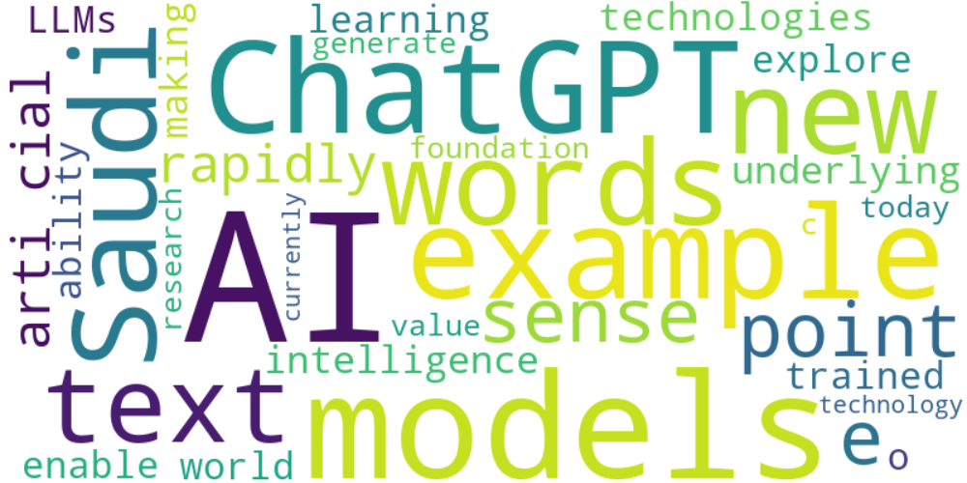

Top 10 words:

- AI: 13

- models: 8

- ChatGPT: 6

- example: 6

- new: 5

- words: 5

- Saudi: 5

- arti: 4

- cial: 4

- text: 4

### Wordcloud of summary



Top 10 words:

- like: 5

- AI: 4

- ChatGPT: 3

- LLMs: 3

- human: 3